Project Report

Project Goals

Primary Objectives
- API Integration
Establish seamless connections to reliable financial data sources for real-time data acquisition
- Data Storage
Design a normalized database schema optimized for time-series financial data storage and retrieval
- Data Processing
Basic analysis of exchange rate and stock data: characteristics and correlation
- Data Visualization
Create an intuitive visual analytics platform for trend identification and pattern recognition

APIs and Data Sources
1. Exchange Rate
URL: https://fixer.io
Description: This API provides real-time and historical exchange rate data for the US Dollar (USD) against major currencies such as the Chinese Yuan (CNY), Euro (EUR), and Great British Pound (GBP).
Data Collection: Daily exchange rate data
Target Currencies: USD to CNY, EUR, GBP conversion pairs

2. Stock Market
URL: https://marketstack.com
Description: This API offers daily market data for international publicly traded companies, such as Apple (AAPL), Microsoft (MSFT), and TSMC (TSM). The data includes daily opening price, closing price, highest price, lowest price, trading volume, and more.
Data Collection: Daily trading data aligned with market operating days
Target Securities: AAPL (Apple Inc.), NVDA (NVIDIA Corporation), TSLA (Tesla Inc.)

Data to Collect
We will collect the following specific data and store it in a SQLite database. We plan to collect a 12‑month historical dataset covering the period from November 2024 to October 2025 (365 days).
1. Exchange Rate Data
Field Name | Data Type | Description
date | DATE | The date of the exchange rate
base_currency | TEXT | Base currency (USD)
target_currency | TEXT | Target currency (CNY, EUR, GBP)
exchange_rate | FLOAT | Exchange rate: 1 unit of base =? target

2. Stock Market Data
Field Name | Data Type | Description
date | DATE | Trading date
symbol | TEXT | Stock symbol, e.g., AAPL, MSFT, TSM
open | FLOAT | Opening price of the day
close | FLOAT | Closing price of the day
high | FLOAT | Highest price of the day
low | FLOAT | Lowest price of the day
volume | INTEGER | Trading volume of the day
exchange | TEXT | Exchange, e.g., NASDAQ, TSE
currency | TEXT | Currency in which the stock is traded, e.g., USD

Achieved Goals

APIs Actually Used
1. Exchange Rate
We were unable to successfully retrieve data from https://fixer.io because it is not a free service. We successfully downloaded data from https://apilayer.com/exchangerates_data-api instead. Since these two websites have similar API interfaces, we only made minor modifications to the code.

2. Stock Market
We successfully downloaded data using the originally planned API https://marketstack.com.

Data Collected
- Date Range
From 2024-11-25 to 2025-11-24
- Data Volume
365 daily exchange rate observations (1,095 rows, 3 rows per day for CNY, EUR, GBP)
250 trading day stock observations (750 rows, 3 rows per day for AAPL, NVDA, and TSLA)

Download Methodology
Due to API rate limiting for free users, we implemented a chunked download approach. Each run downloads only 8 days of data (3 rows each day in db). We designed 2 main download functions:

download_exchange_rate_limit_25(start_date: str, db_path: str)
download_stock_limit_25(start_date: str, db_path: str)

These functions encapsulate the entire download process: API interaction, data transformation, and SQLite database storage. By specifying date ranges, we control the amount of data downloaded and stored in each run. The entire dataset collection required approximately 45 separate executions.

Database Architecture
The database consists of 4 tables:
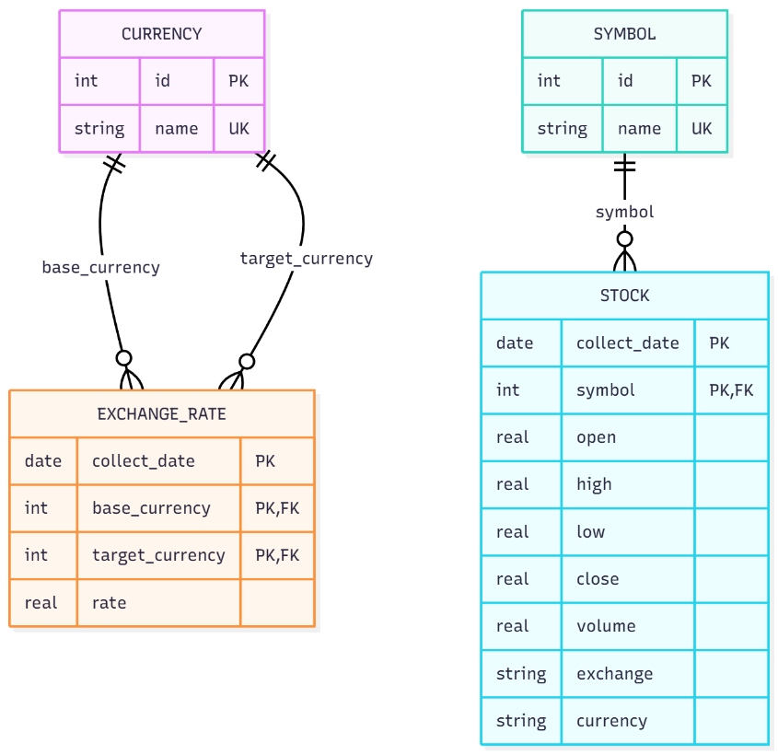
To avoid string duplication, we designed separate tables for currencies (USD, CNY, EUR, GBP) and stock symbols (AAPL, NVDA, TSLA):

Currency Table - Stores currency codes with unique IDs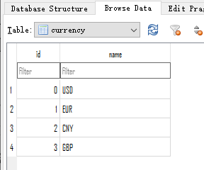
Symbol Table - Stores stock symbols with unique IDs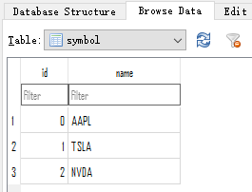
Exchange Rate Table - Stores daily exchange rate data with foreign key relationships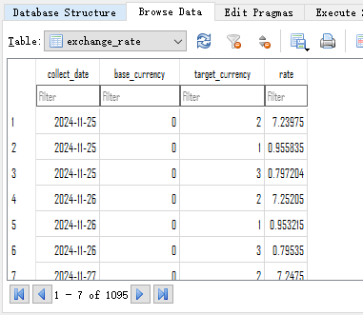
Stock Table - Stores daily trading data with foreign key relationships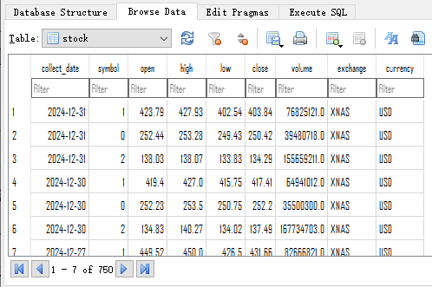

Problems Faced and Solutions

Data Download Failures
Problem: Downloading too much data at once and making requests too frequently
Solution: Limited each download to 10 days of data, limited to 3-4 downloads per day, and implemented data integrity verification.

API Download Exceptions
Problem: Due to network issues or API key limits, APIs sometimes returned error data.
Solution: Added exception handling code to display API error messages for failure analysis. Implemented retry logic for network-related issues and registered multiple accounts for rate limit problems.

Data Duplication
Problem: Sometimes APIs return only part of the expected data, causing data duplication when re-downloading.
Solution: Used INSERT OR IGNORE INTO statements to prevent duplicate data insertion into database tables.

Data Inconsistency
Problem: Exchange rate data is available daily, while stock data only exists on business days. This caused data length inconsistencies when comparing the two datasets.
Solution: When retrieving exchange rate data, used SQL WHERE clause constraints to only return data for dates that exist in the stock table. Therefore, we actually only process exchange rate data for trading days.

Metrics Calculation

Data Retrieval
Since the exchange_rate table does not directly store strings like "USD", "CNY", etc., data retrieval requires JOIN operations:
Retrieving exchange rate data requires both exchange_rate and currency tables
Retrieving stock data requires both stock and symbol tables

Metric Calculations
Based on the raw data collected, we calculated the following metrics for further analysis and visualization:
Metric Name | Calculation Method | Description
Exchange Rate Change (%) | (Today's Rate - Yesterday's Rate) / Yesterday's Rate × 100 | Measures the daily fluctuation of currencies
Stock Price Change (%) | (Today's Close - Yesterday's Close) / Yesterday's Close × 100 | Measures the daily change in stock prices
Correlation Coefficient | Pearson correlation coefficient between exchange rates and stock prices | Analyzes the relationship between exchange rates
Maximum Exchange Rate Volatility | iterate through all dates​ and find the day with the largest absolute value​ of exchange rate change | Maximum daily volatility
Maximum Stock Price Volatility | iterate through all dates​ and find the day with the largest absolute value​ of stock price change | Maximum daily volatility
We chose exchange rates for USD against CNY, EUR, and GBP. For stocks, we will choose large international companies such as AAPL, NVDA and TSLA.

Calculation Results
1. Correlation Analysis Matrix
Stock Symbol | USD/CNY | USD/EUR | USD/GBP
AAPL | -0.09 | 0.01 | -0.18
NVDA | -0.00 | 0.03 | -0.06
TSLA | -0.06 | 0.02 | -0.11
Through correlation coefficient calculation, we found weak or no linear correlation between exchange rate changes and stock price changes.

2. Maximum Daily Volatility Analysis
Exchange Rate Volatility:
USD/CNY: Maximum change of +1.45% on March 28, 2025
USD/EUR: Maximum change of -2.72% on April 10, 2025
USD/GBP: Maximum change of +1.58% on April 4, 2025
Stock Price Volatility:
AAPL: Maximum change of -8.96% on April 3, 2025
NVDA: Maximum change of -17.75% on January 27, 2025
TSLA: Maximum change of -16.53% on June 5, 2025

Results Storage
The calculation results were saved to a text file with the following format:
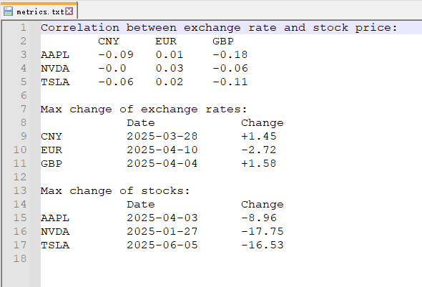

Data Visualization

Exchange Rate Trend Analysis
Type: Line chart showing the trend of USD exchange rates against CNY/EUR/GBP over time
Purpose: Identify long-term currency trends and volatility patterns
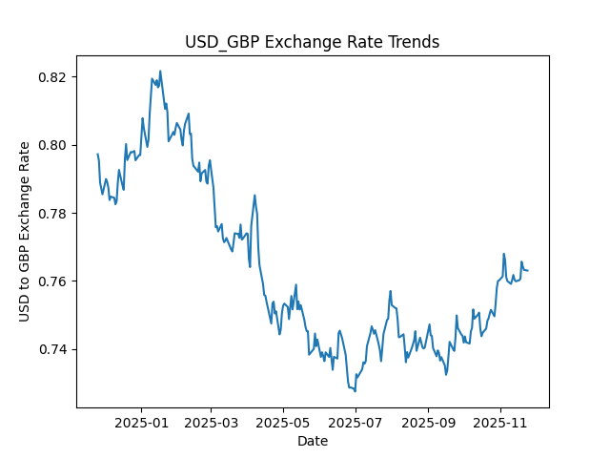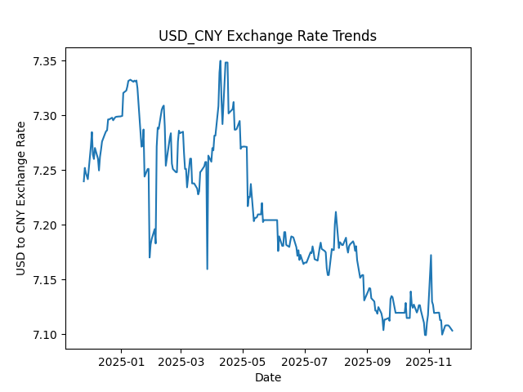

Stock Closing Price Trend
Type: Line chart showing the daily closing prices of stocks such as AAPL, NVDA, TSLA
Purpose: Analyze stock price movements and identify significant market events
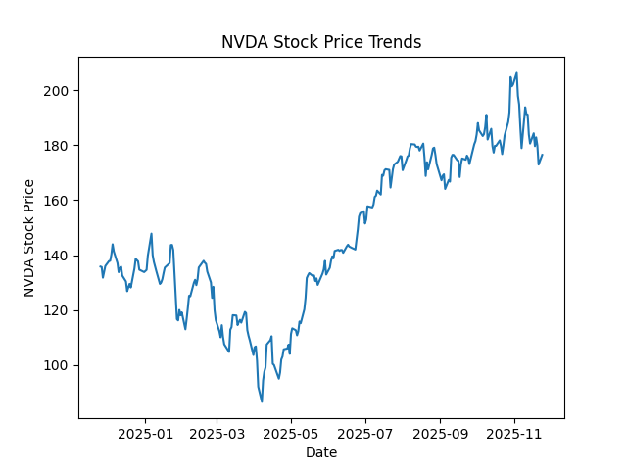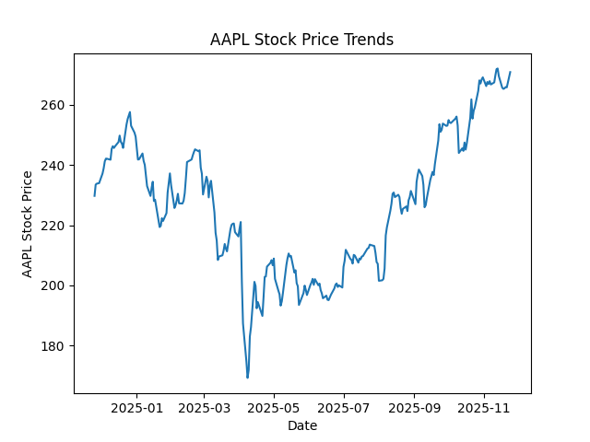

Exchange Rate vs Stock Price Comparison
Type: Chart comparing the trend of exchange rates and a specific stock price over the same period
Purpose: Visually assess potential relationships between currency fluctuations and stock performance
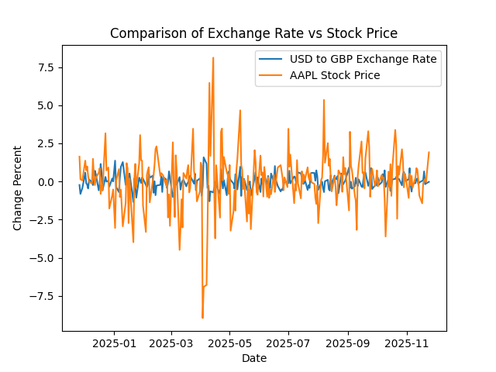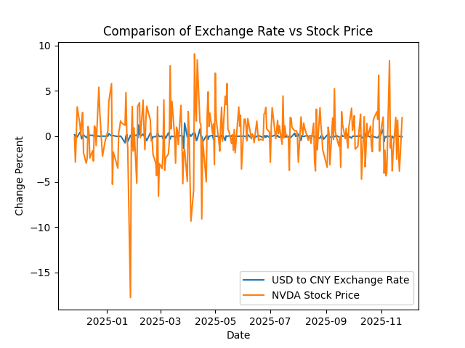

Exchange Rate vs Stock Price Scatter Plot
Type: Scatter plot to analyze the statistical relationship between exchange rates and stock prices
Finding: Points are widely scattered without directional shape, confirming weak correlation between exchange rates and stock prices
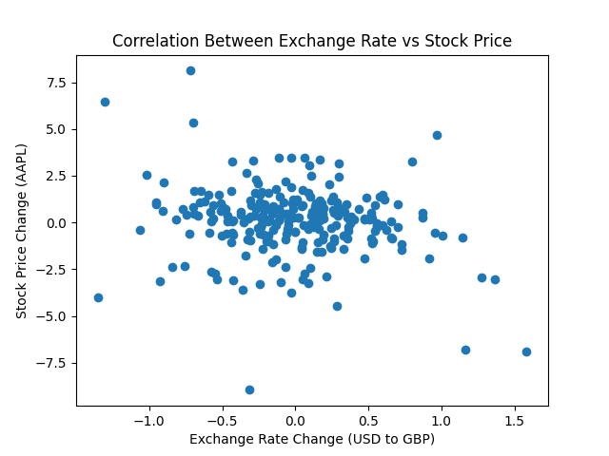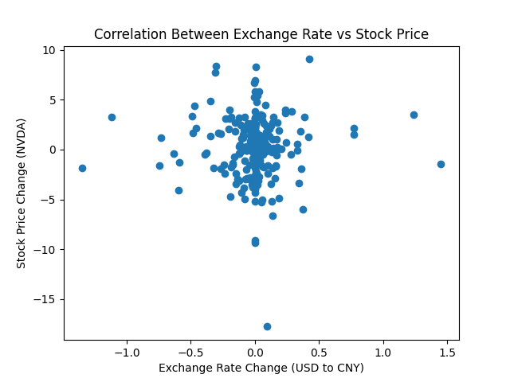

Running Instructions

System Requirements
Python: 3.8+ with virtual environment recommended
Dependencies: matplotlib, requests, sqlite
Network: Stable internet connection for API access

Program running
All four Python files are executable and each demonstrates the functionality of a different module.

download.py
This module demonstrates the entire process from API request to database storage.
Command:​
python download.py
Result:
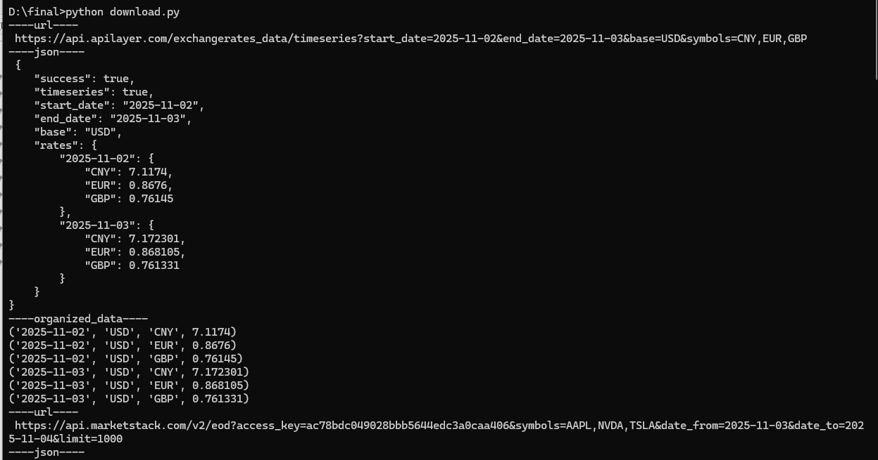
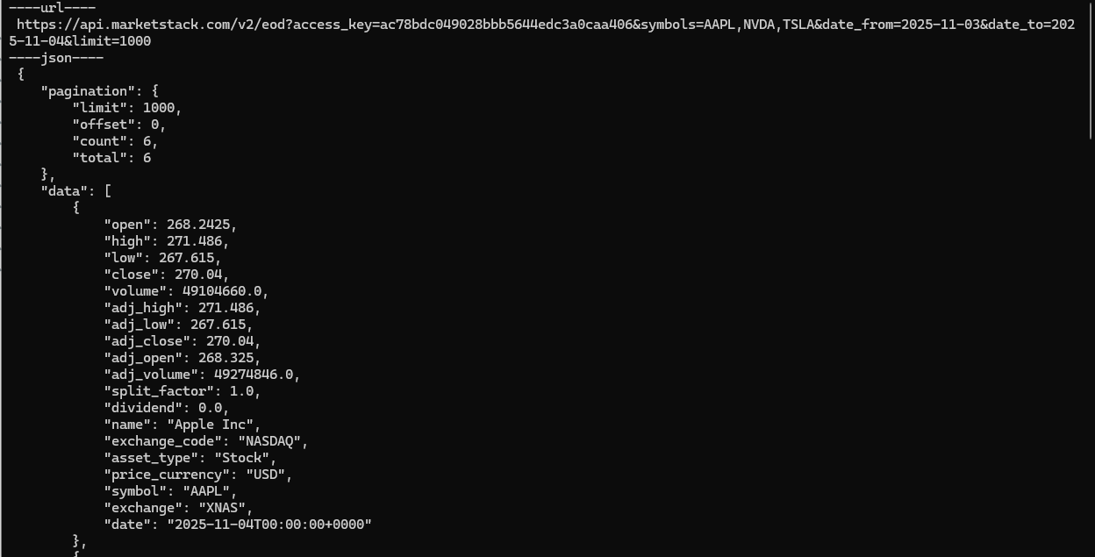
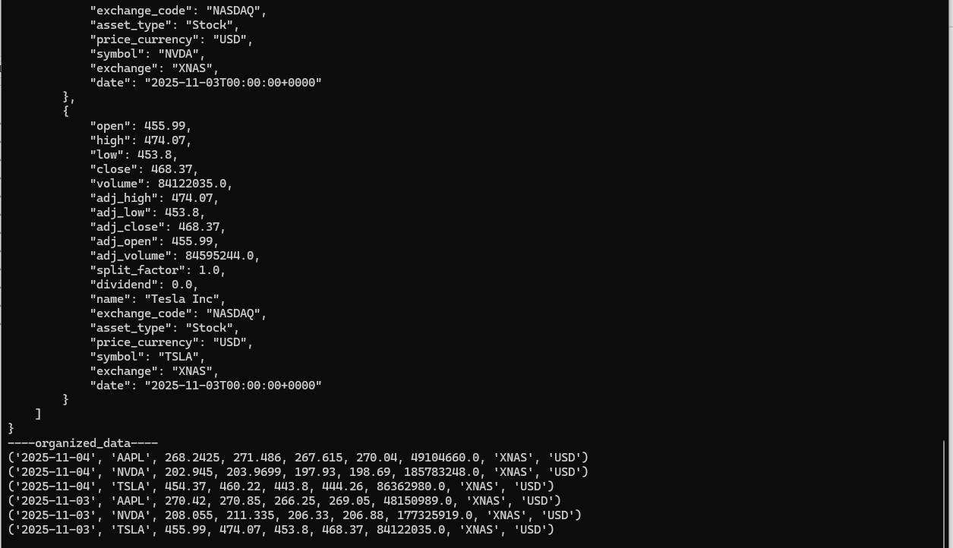

database.py - Database Management Module
This module demonstrates the processes of database table creation, data insertion, and data retrieval.
Command:
python database.py
Result:
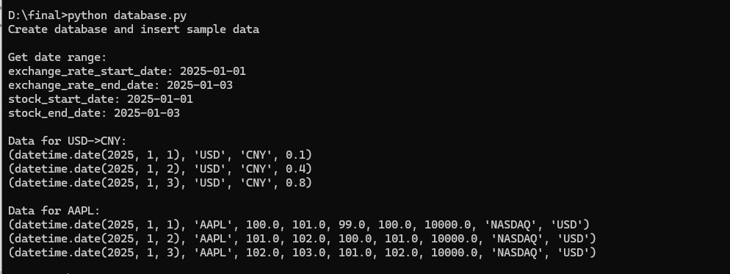

metrics_calculation.py - Statistical Analysis Module
This module demonstrates statistical calculation and saving the results.
Command:
python metrics_calculation.py
Result:
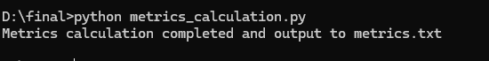
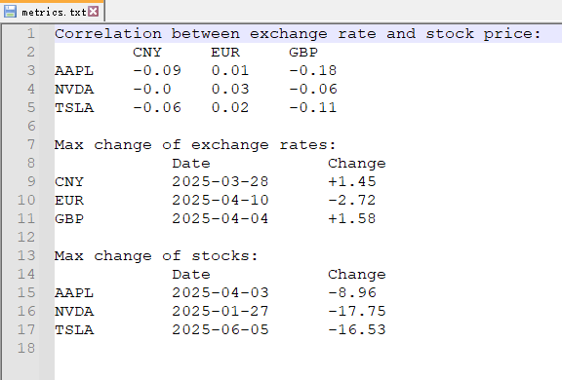

visualization.py - Data Visualization Module
This module generates plots and saves them as PNG files.
Command:
python visualization.py
Result:
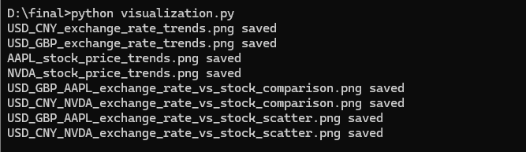

Function Diagram

Program structure
The project consists of 4 core Python files, each responsible for specific functional modules:

download.py - Data Collection Module
Person in Charge: Bojun Zhang

The download.py module serves as the project's data acquisition engine, responsible for establishing API connections to both ExchangeRate-API and MarketStack, implementing intelligent batch downloading strategies for historical exchange rates and stock data, transforming raw JSON API responses into structured tuple formats, creating CSV backup files for data redundancy, and incorporating robust error handling mechanisms to gracefully manage API rate limits and network exceptions, ensuring reliable data collection for the entire financial analysis pipeline.
Function Name | Input Parameters | Return Description | Description
get_exchange_rate_data | base_currency: str  target_currencies: list[str]  start_date: str  end_date: str  api_key: str | str (JSON data)  str (URL) | Fetches historical exchange rate data from ExchangeRate-API for specified date range and currencies
organize_exchange_rate_data | exchange_data: str (JSON) | list[tuple] | Converts JSON exchange rate data into structured tuples (date, base, target, rate)
export_exchange_rate_to_csv | data: list[tuple]  filename: str | bool | Exports organized exchange rate data to CSV file with headers
get_stock_data | symbols: list[str]  start_date: str  end_date: str  api_key: str | str (JSON data)  str (URL) | Fetches historical stock market data from MarketStack API for specified symbols and date range
organize_stock_data | stock_data: str (JSON) | list[tuple] | Converts JSON stock data into structured tuples (date, symbol, OHLC, volume, exchange, currency)
export_stock_to_csv | data: list[tuple]  filename: str | bool | Exports organized stock data to CSV file with headers
download_exchange_rate_data | base_currency: str  target_currencies: list[str]  start_date: str  end_date: str  cur: Cursor  conn: Connection  debug: bool | None | Complete workflow: API call → data organization → CSV export → database storage for exchange rates
download_stock_data | symbols: list[str]  start_date: str  end_date: str  cur: Cursor  conn: Connection  debug: bool | None | Complete workflow: API call → data organization → CSV export → database storage for stock data
exchange_data_collection | None | None | Orchestrates batch collection of exchange rate data for entire project period using 10-day chunks
stock_data_collection | None | None | Orchestrates batch collection of stock data for entire project period using 10-day chunks
demo | None | None | Demonstrates complete data collection workflow with 2-day sample data and debug logging

database.py - Database Management Module
Person in Charge: Bojun Zhang

The database.py module serves as the foundational data management layer of the project, responsible for establishing and maintaining SQLite database connections, designing and implementing a normalized database schema with four interconnected tables (currency, symbol, exchange_rate, and stock), efficiently storing API-collected financial data into the database, providing optimized query interfaces for retrieving exchange rates and stock information, and maintaining foreign key relationships to ensure data integrity and eliminate redundancy in currency and stock symbol storage throughout the financial analysis system.
Function Name | Input Parameters | Return Description | Description
connect_database | db_name: str | tuple[Cursor, Connection] | Establishes connection to SQLite database and returns cursor and connection objects
set_up_database | db_name: str | tuple[Cursor, Connection] | Sets up database connection, registers date converters, creates currency/symbol tables, and initializes database schema
set_up_currency_symbol_table | currencies: list[str]  symbols: list[str]  cur: Cursor  conn: Connection | None | Creates and populates currency and symbol lookup tables with provided data
create_database_tables | cur: Cursor  conn: Connection | None | Creates exchange_rate and stock tables with proper schema and constraints
get_currency_id | currency: str  cur: Cursor  conn: Connection | int | Retrieves database ID for a given currency name
get_symbol_id | symbol: str  cur: Cursor  conn: Connection | int | Retrieves database ID for a given stock symbol
store_exchange_rates_to_db | data: list[tuple]  cur: Cursor  conn: Connection | None | Stores organized exchange rate data into database with foreign key resolution
store_stock_data_to_db | data: list[tuple]  cur: Cursor  conn: Connection | None | Stores organized stock market data into database with foreign key resolution
get_date_range | cur: Cursor  conn: Connection | tuple[tuple[date, date], tuple[date, date]] | Returns date ranges for exchange rates and stock data in database
get_exchange_rate | base_currency: str  target_currency: str  cur: Cursor  conn: Connection | list[tuple[date, str, str, float]] | Retrieves exchange rate data for specific currency pair filtered by stock trading dates
get_stock_data | symbol: str  cur: Cursor  conn: Connection | list[tuple[date, str, float, float, float, float, float, str, str]] | Retrieves comprehensive stock data for specific symbol ordered by date

metrics_calculation.py - Statistical Analysis Module
Person in Charge: Ruby Xu

The metrics_calculation.py module functions as the analytical engine of the project, responsible for computing daily percentage changes to measure market movements, implementing custom Pearson correlation coefficient analysis to examine relationships between exchange rates and stock prices, conducting volatility analysis to identify maximum daily fluctuations and market patterns, and generating comprehensive statistical reports that transform raw financial data into actionable insights for the overall investment analysis framework.
Function Name | Input Parameters | Return Description | Description
calculate_exchange_rate_changes | base_currency: str  target_currency: str  cur: Cursor  conn: Connection | list[tuple[date, float]] | Calculates daily percentage changes in exchange rates using formula: (Today - Yesterday) / Yesterday × 100
find_max_exchange_rate_change_date | base_currency: str  target_currency: str  cur: Cursor  conn: Connection | tuple[date, float] | Identifies date and value of maximum absolute exchange rate change
calculate_stock_price_changes | stock_symbol: str  cur: Cursor  conn: Connection | list[tuple[date, float]] | Calculates daily percentage changes in stock closing prices using formula: (Today - Yesterday) / Yesterday × 100
find_max_stock_change_date | stock_symbol: str  cur: Cursor  conn: Connection | tuple[date, float] | Identifies date and value of maximum absolute stock price change
perform_correlation_analysis | exchange_data: list[tuple[date, float]]  stock_data: list[tuple[date, float]] | float | Calculates Pearson correlation coefficient between exchange rate and stock price changes using pure Python implementation
main_metrics_calculation | None | None | Main execution function that performs all statistical calculations and generates metrics.txt report file

visualization.py - Data Visualization Module
Person in Charge: Ruby Xu

The visualization.py module serves as the project's data presentation layer, responsible for generating comprehensive trend charts displaying exchange rate and stock price movements over time, creating comparative analysis charts that overlay currency fluctuations against stock performance for pattern identification, producing scatter plots that visualize statistical correlations between different financial instruments, and exporting all visualizations as high-quality PNG image files to effectively communicate complex financial relationships and insights to stakeholders.
Function Name | Input Parameters | Return Description | Description
calculate_exchange_rate_changes | base_currency: str  target_currency: str  cur: Cursor  conn: Connection | list[tuple[date, float]] | Calculates daily percentage changes in exchange rates using formula: (Today - Yesterday) / Yesterday × 100
find_max_exchange_rate_change_date | base_currency: str  target_currency: str  cur: Cursor  conn: Connection | tuple[date, float] | Identifies date and value of maximum absolute exchange rate change
calculate_stock_price_changes | stock_symbol: str  cur: Cursor  conn: Connection | list[tuple[date, float]] | Calculates daily percentage changes in stock closing prices using formula: (Today - Yesterday) / Yesterday × 100
find_max_stock_change_date | stock_symbol: str  cur: Cursor  conn: Connection | tuple[date, float] | Identifies date and value of maximum absolute stock price change
perform_correlation_analysis | exchange_data: list[tuple[date, float]]  stock_data: list[tuple[date, float]] | float | Calculates Pearson correlation coefficient between exchange rate and stock price changes using pure Python implementation
main_metrics_calculation | None | None | Main execution function that performs all statistical calculations and generates metrics.txt report file

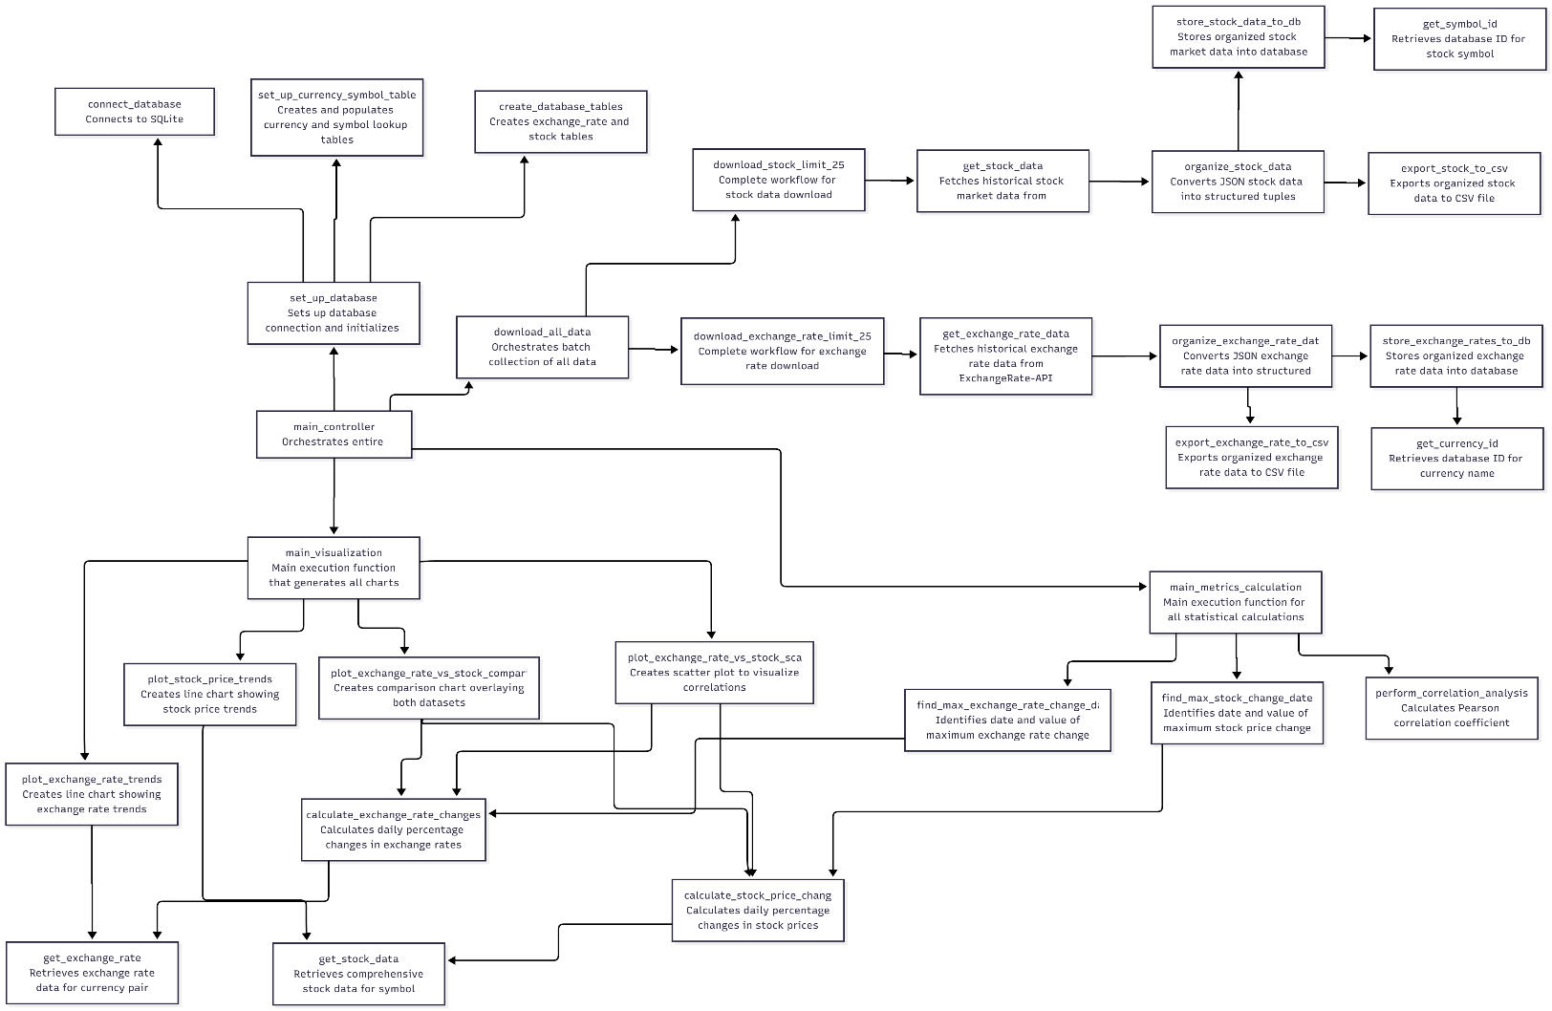
Updated function diagram

Resources
Date | Issue Description | Location of Resource | Result | Did it solve the issue?
11-18 | Need to integrate currency exchange rate API for historical data | https://apilayer.com/marketplace/exchangerates_data-api | Successfully integrated API with endpoint format, found API keys and authentication methods | Yes - API integration complete with proper request formatting
11-18 | Require stock market data API for historical OHLCV data | https://marketstack.com/documentation | Obtained API key, learned endpoint structure for historical stock data | Yes - Stock market data retrieval implemented
11-19 | Design normalized database structure for financial data | https://www.sqlite.org/docs.html | Created 4-table schema with proper foreign key relationships | Yes - Efficient database structure implemented
11-22 | Create charts for financial data analysis | https://matplotlib.org/stable/contents.html | Implemented line charts, scatter plots, and comparison charts | Yes - All visualization requirements met
11-23 | Create visual workflow diagrams for project documentation | https://mermaid.js.org/intro | Created comprehensive flow diagrams showing data flow and function relationships | Yes - Project visualization complete
11-23 | Understand Pearson correlation coefficient mathematical principles | https://www.scribbr.com/statistics/pearson-correlation-coefficient/ | Learned mathematical foundation and interpretation guidelines for correlation analysis | Yes - Enhanced understanding of correlation statistics

